AIRLINE RESERVATION SYSTEM

BY

Harshith Appari



DECLARATION

**Airline reservation systems** (**ARS**) are systems that allow an airline to sell their inventory (seats). It contains information on schedules and fares and contains a database of reservations (or passenger name records) and of tickets issued (if applicable). ARSs are part of passenger service systems (PSS), which are applications supporting the direct contact with the passenger.

ARS eventually evolved into the computer reservations system (CRS). A computer reservation system is used for the reservations of a particular airline and interfaces with a global distribution system (GDS) which supports travel agencies and other distribution channels in making reservations for most major airlines in a single system.

1950s, airline reservations used manual systems at centralized reservation centers, which consisted of groups of people in a room with physical cards that represented inventory, in this case, seats on airplanes. In the late 1950s, American

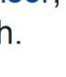Airlines wanted a system that would allow real-time access to flight details in all of its offices, and the integration and automation of its booking and ticketing processes. It introduced an electronic reservations system, Magnetronic Reservisor, in 1952. In 1964, it developed the Sabre (Semi-Automated Business Research.

**CONTENTS**

1. Abstract view
2. Schema Representation 3.ER model Representation 4.Relational Model

5.SQL Commands 6.SQL Queries

ABSTRACT VIEW:

American Airlines was started in 1930 via a union of more than eighty small airlines.

The two organizations from which American Airlines was originated were Robert aircraft and Colonial Air Transport

The former was first created in Missouri in 1921, with both being merged in 1929 into holding company The Aviation Corporation.

This, in turn, was made in 1930 into an operating company and rebranded as American Airways.

In 1934, when new laws and attrition of mail contracts forced many airlines to reorganize, the corporation redid its routes into a connected system and was renamed American Airlines.

Between 1970 and 2000, the company grew into being an international carrier, purchasing Trans World Airlines in 2000.

American had a direct role in the development of the DC-3, which resulted from a marathon telephone call from American Airlines CEO C. R. Smith to Douglas Aircraft Company founder Donald Wills Douglas Sr., when Smith persuaded a reluctant Douglas to design a sleeper aircraft based on the DC-2 to replace American's Curtiss Condor II biplanes.

(The existing DC-2's cabin was 66 inches (1.7 m) wide, too narrow for side-by-side berths.) Douglas agreed to go ahead with development only after Smith informed him of American's intention to purchase 20 aircraft.

ARS eventually evolved into the computer reservations system (CRS). A computer reservation system is used for the reservations of a particular airline and interfaces with a global distribution system (GDS) which supports travel.

**SCHEMA REPRESENTATION**

|  |  |
| --- | --- |
| **ENTITIES** | **ATTRIBUTES** |
| Passenger | Id , name , ph.no , age |
| price | Amount, Flight number |
| Payment Receipt | RE_ID , Payment Method |
| Destination | SNO , From Destination ,to Destination |
| Airport | Aid , Location , HelpLine |
| Flight class | FLC_ID , Flight class |

ENTITY RELATIONSHIP DIAGRAM

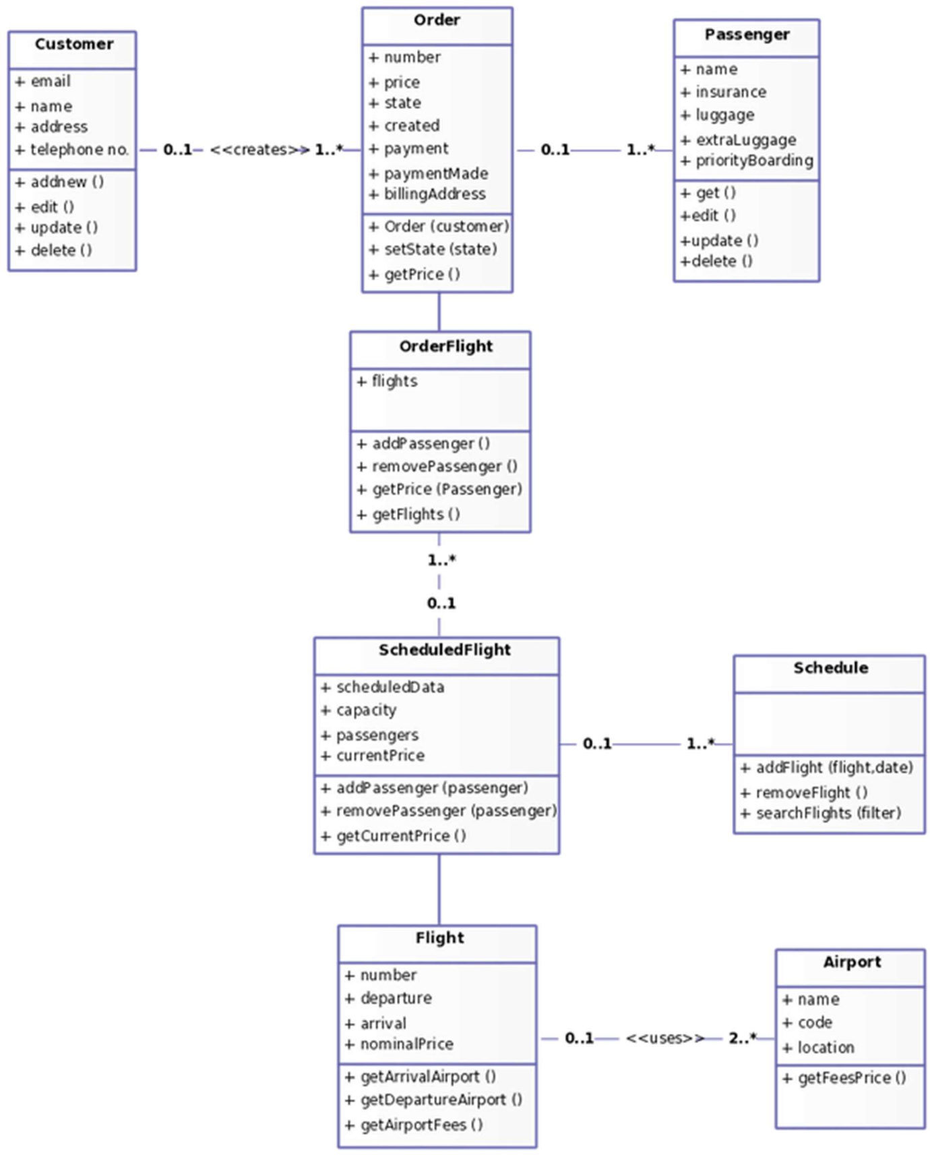

# ER MODEL:

ER model stands for an Entity-Relationship model. It is a high-level data model. This model is used to define the data elements and relationship for a specified system.

It develops a conceptual design for the database. It also develops a very simple and easy to design view of data.

In ER model the database structure is portrayed a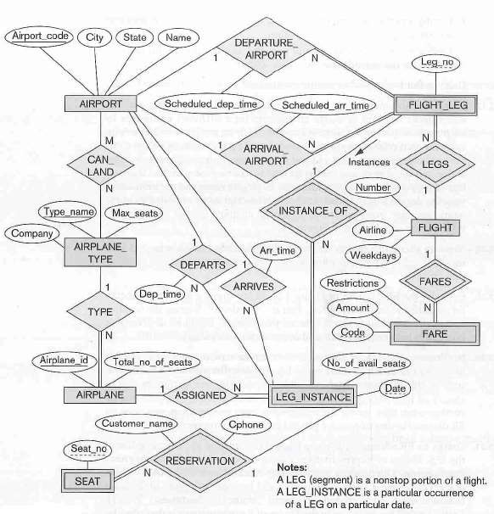s a diagram called an entity- relationship diagram.

RELATIONAL MODEL

It is an approach to logically represent and manage the data stored in a database by storing data in tables.

SQL Commands

DDL (Data Definition Language)

➢ Create

➢ Drop

➢ Alter

➢ Truncate

➢ Rename

DML (Data Manipulation Language)

➢ Insert

➢ Update

➢ Delete

➢ Select

TCL (Transaction Control Language)

➢ Commit

➢ Roll back

➢ Save point

DCL (Data Control Language)

➢ Grant

➢ Revoke

***AIRLINE RESERVATION SYSTEM-***

TABLE CREATED INSERT THE VALUES

## TABLE CREATION

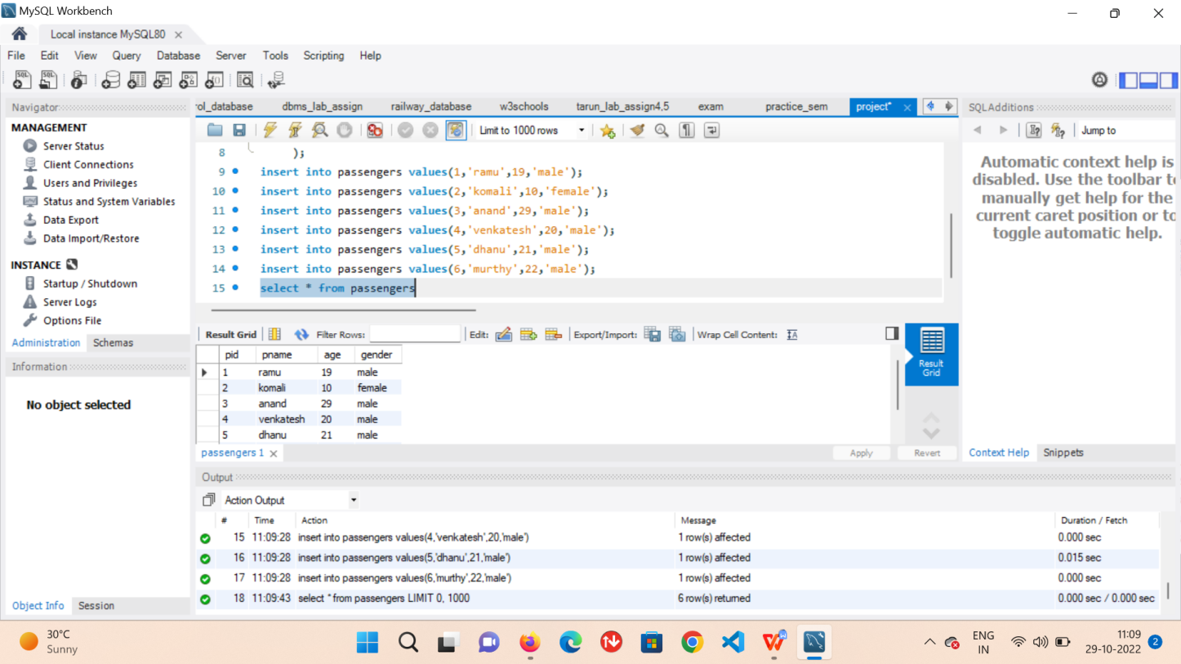

INSERT THE VALUES

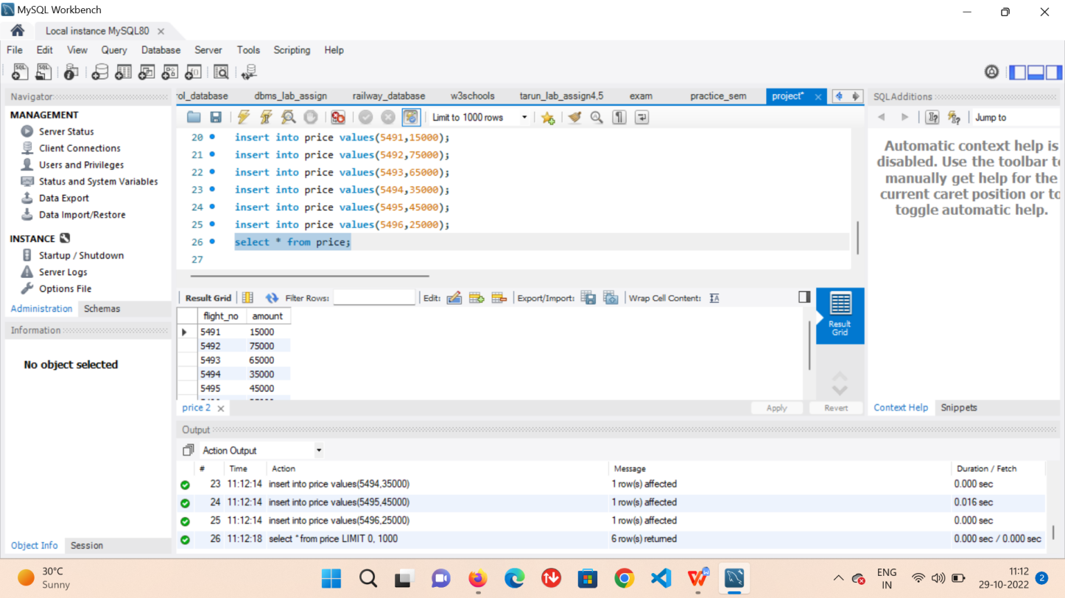

**RESERVES**

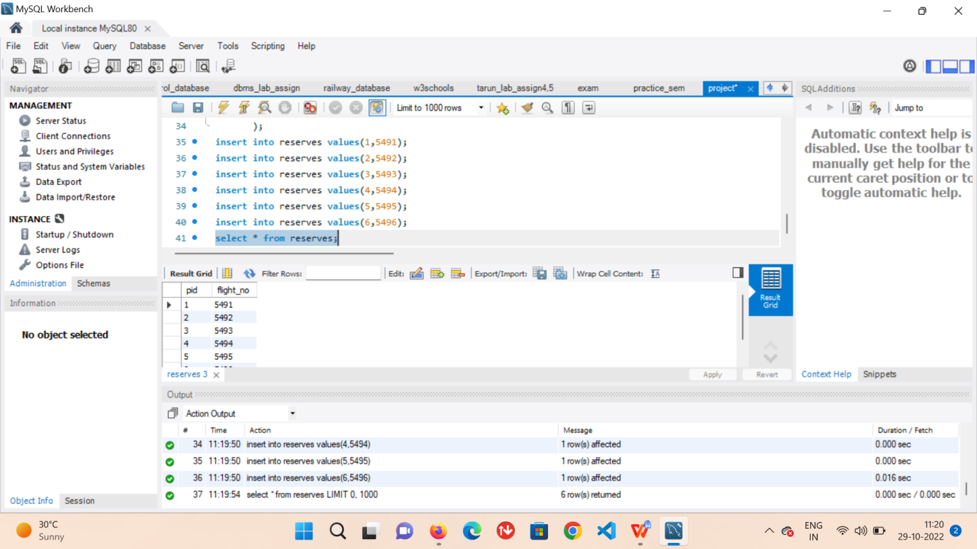

**PAYMENT**

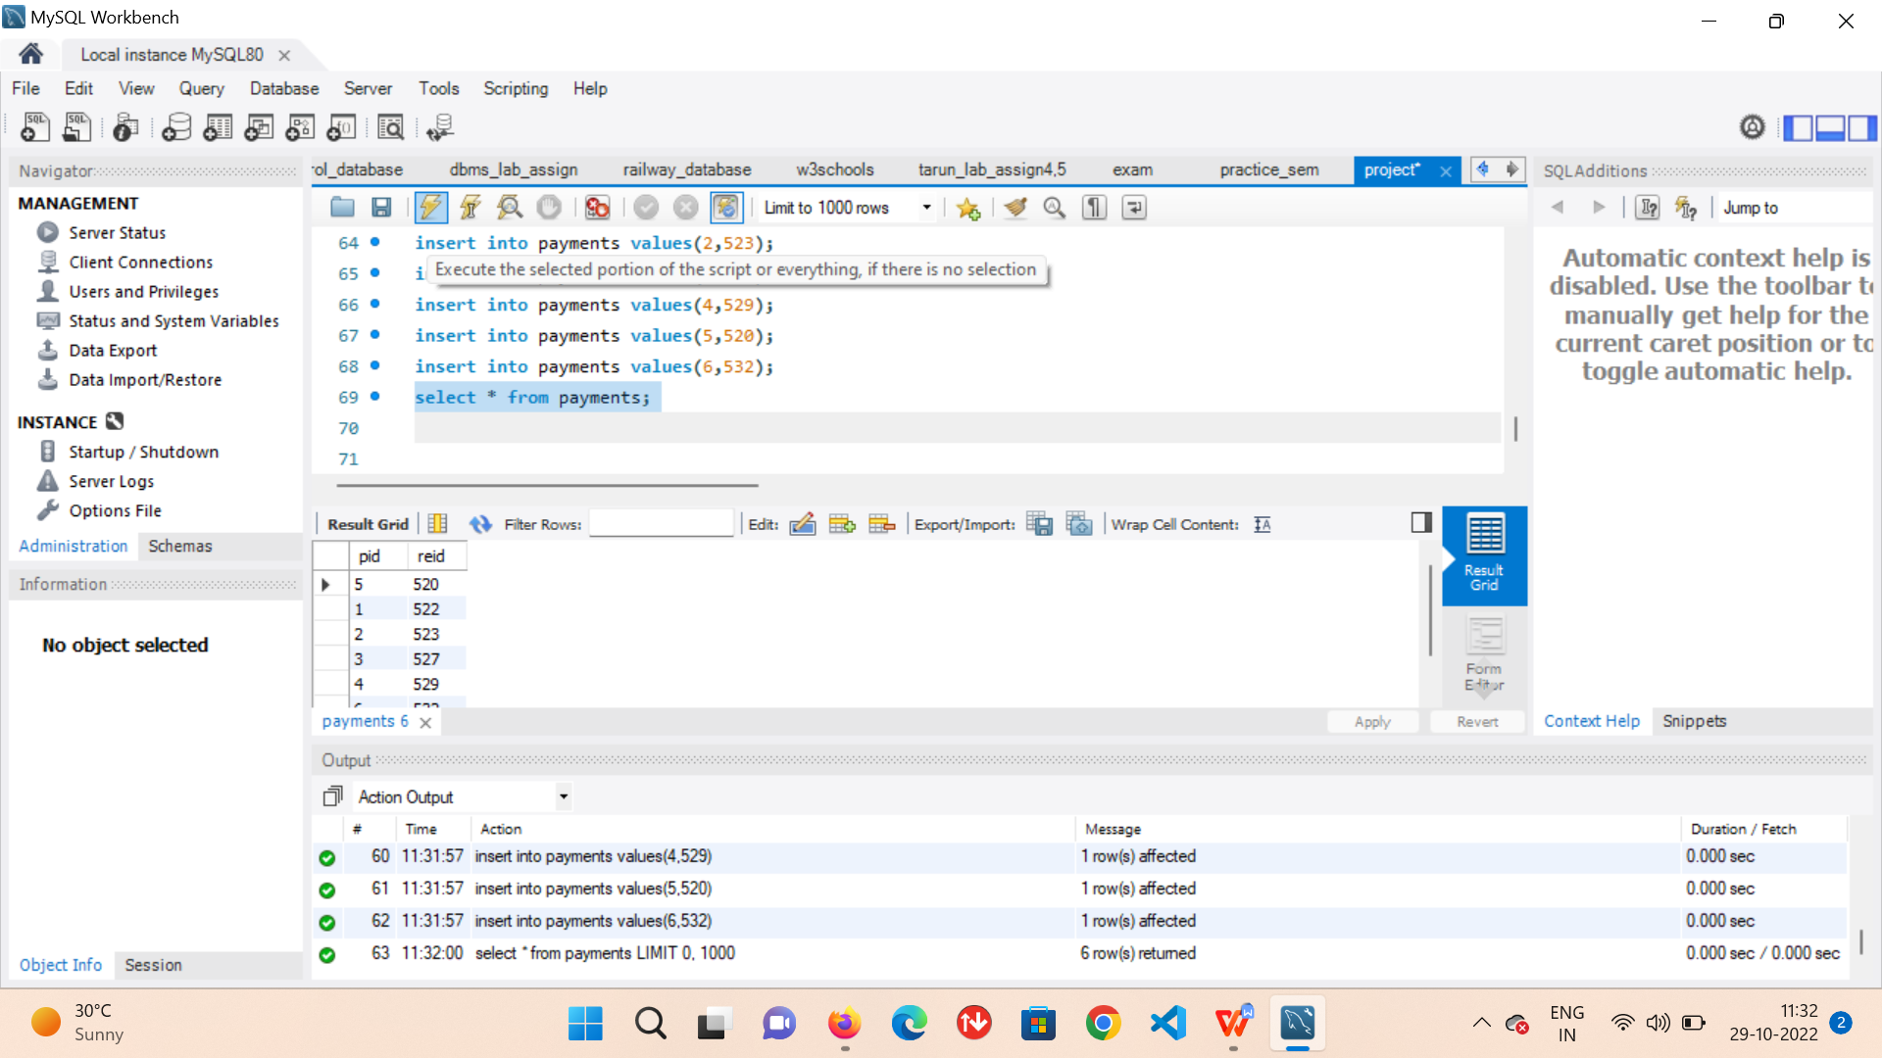

**DESTINATION**

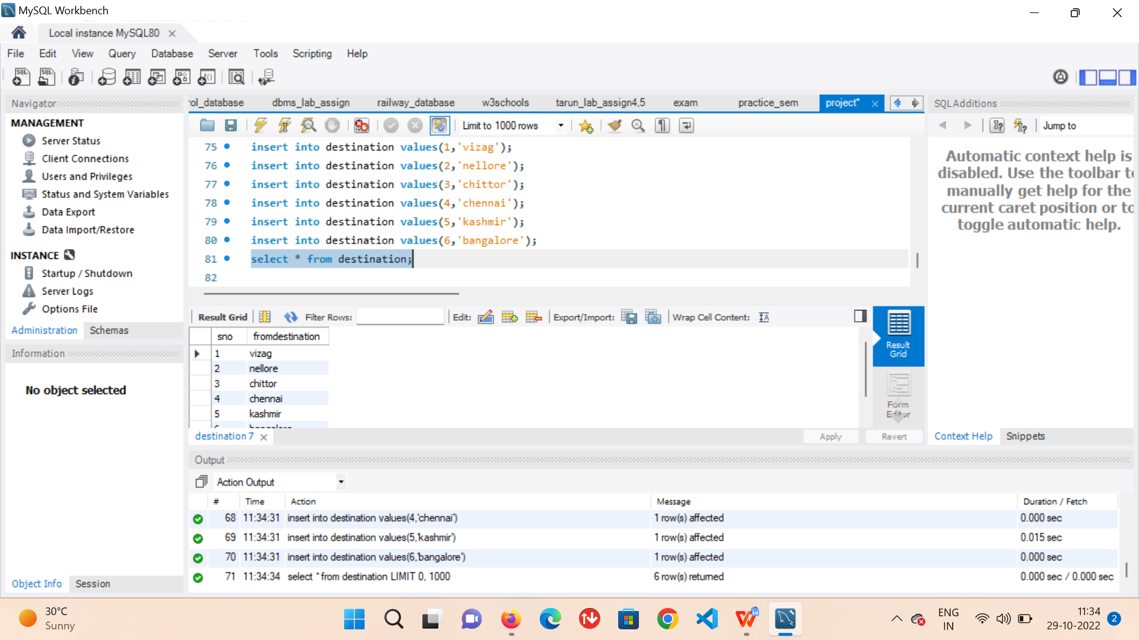

**PAYMENT**



**VALUES INSERTION**



**FLIGHT CLASS**

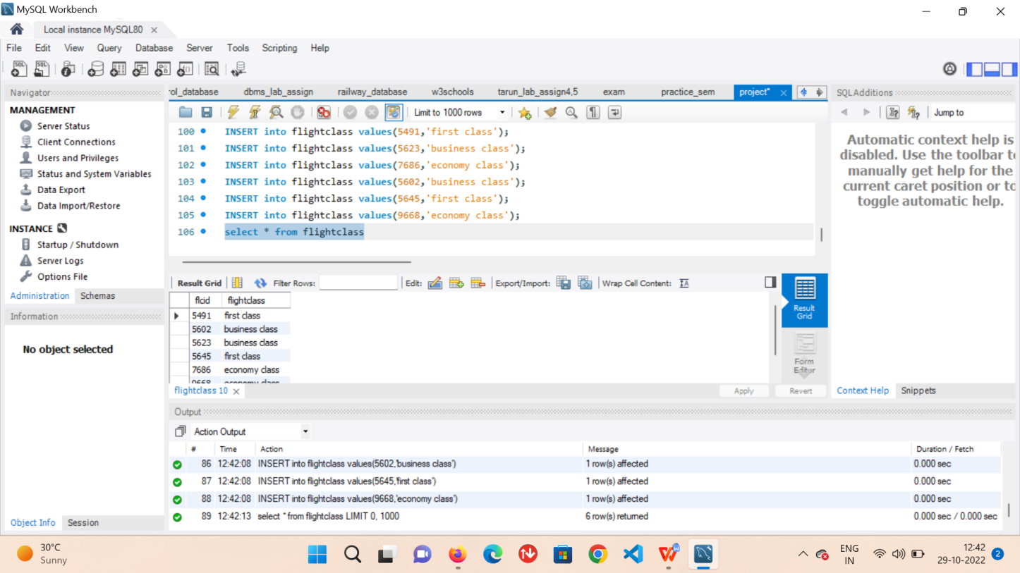

**JOURNEY DATE**

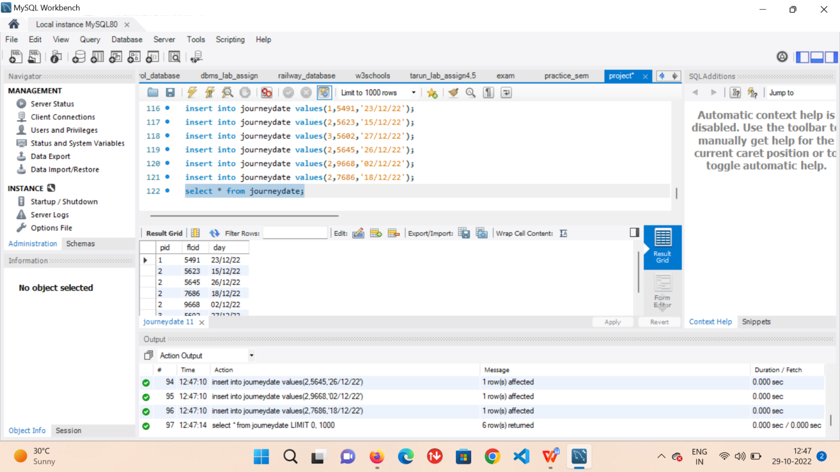

**AIRPORT**

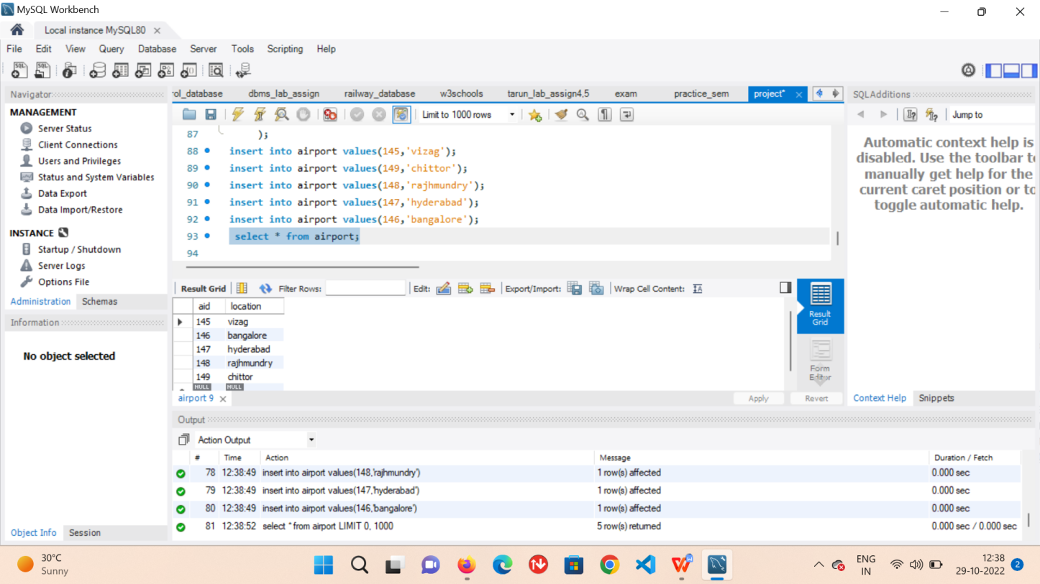

# SQL QUERIES

Find the Passenger name and phone number whose age is greater than 20

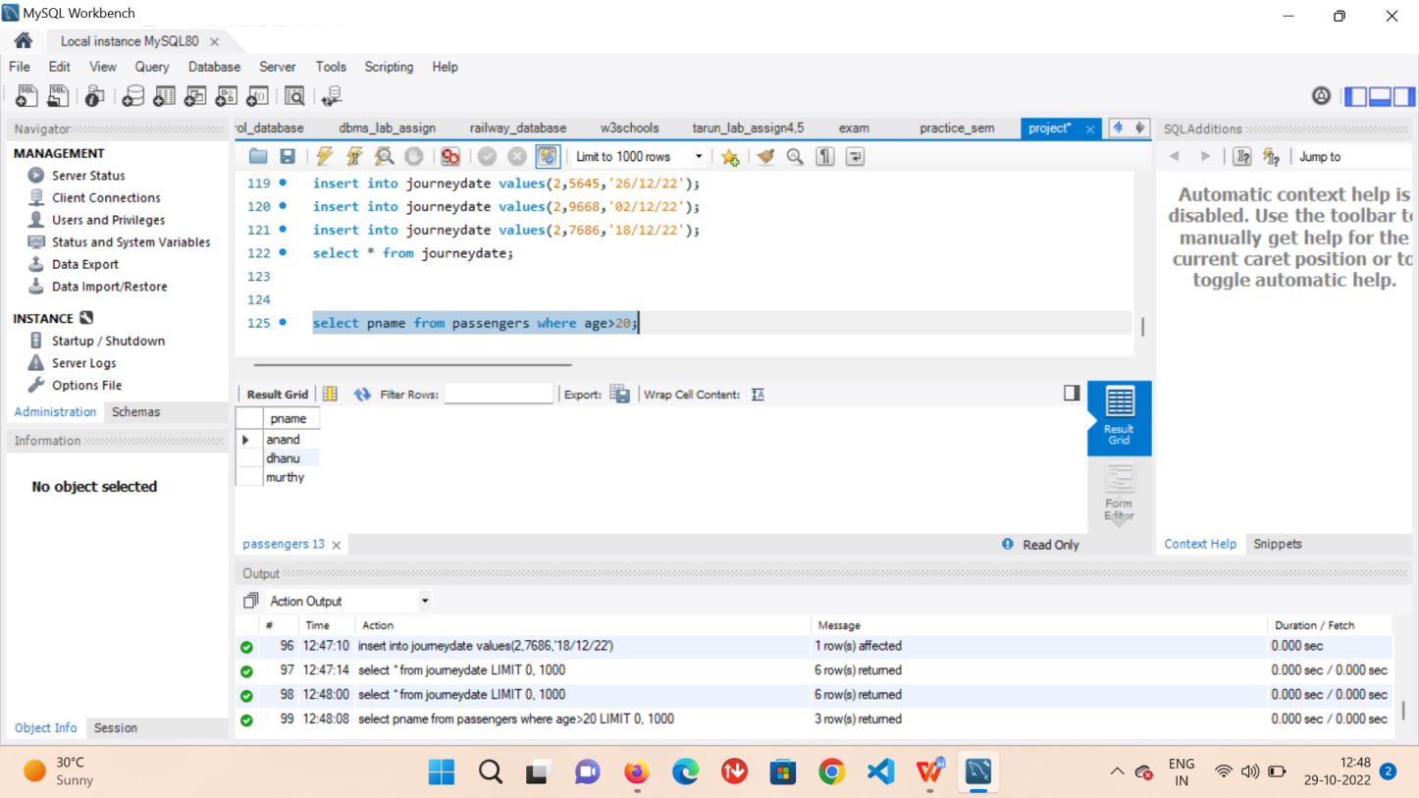

Find the name of the passenger who reserved on 23rd December22

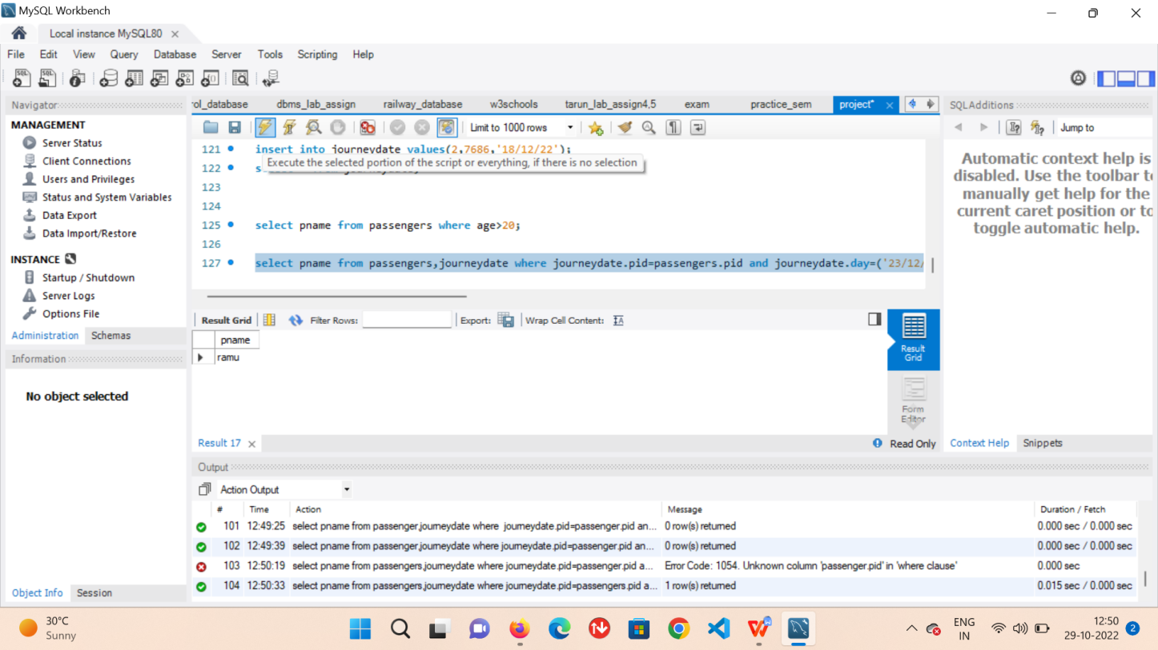

Find the passenger details who reserved flight

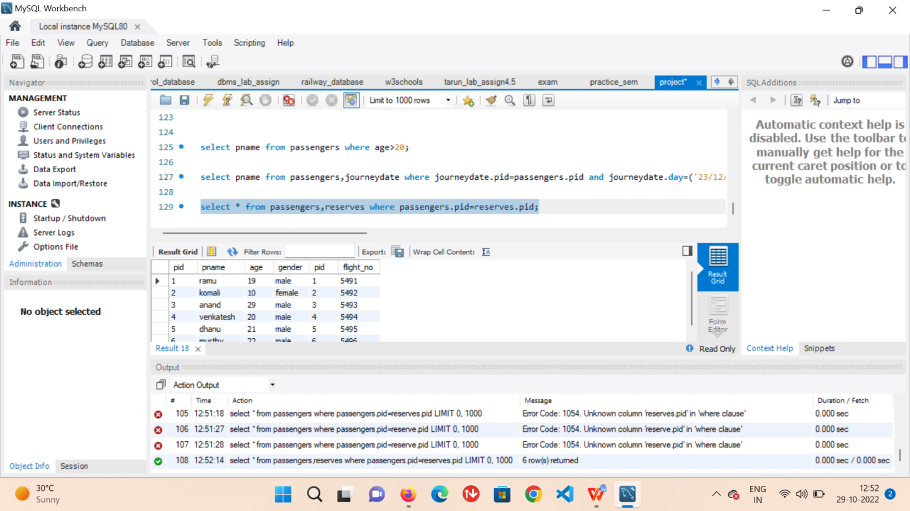

**RELATIONAL ALGEBRA**

Find the passenger who reserved both Economy class and Business class

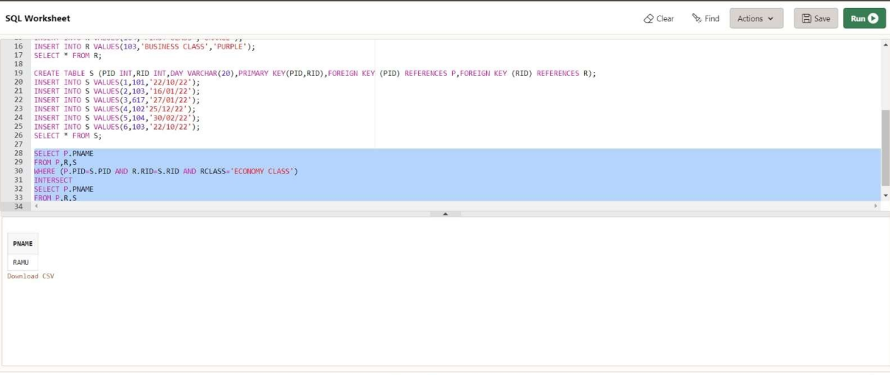

Find the passenger who reserved Either Economy class and Business class

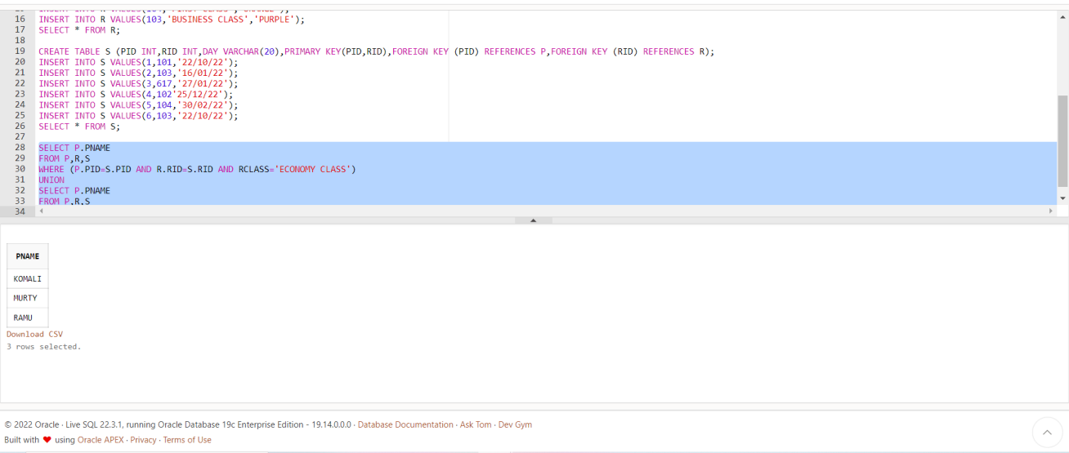

Find the passenger who reserved in Economy class but not in Business class

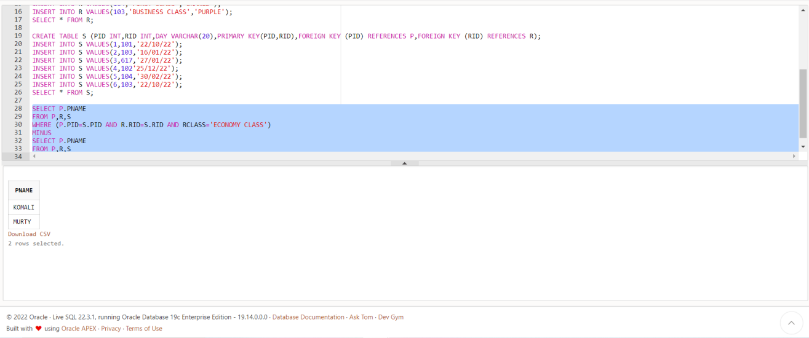

Aggregate Operators

## Max ( )

Min ( )

Sum ( )

Count ( )

Avg ( )

**FIND MAXIMUM AGE OF PASSENGER-**

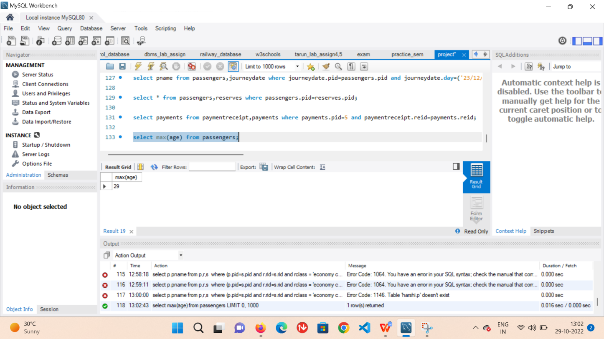

FIND THE AVERAGE PRICE OF FLIGHT

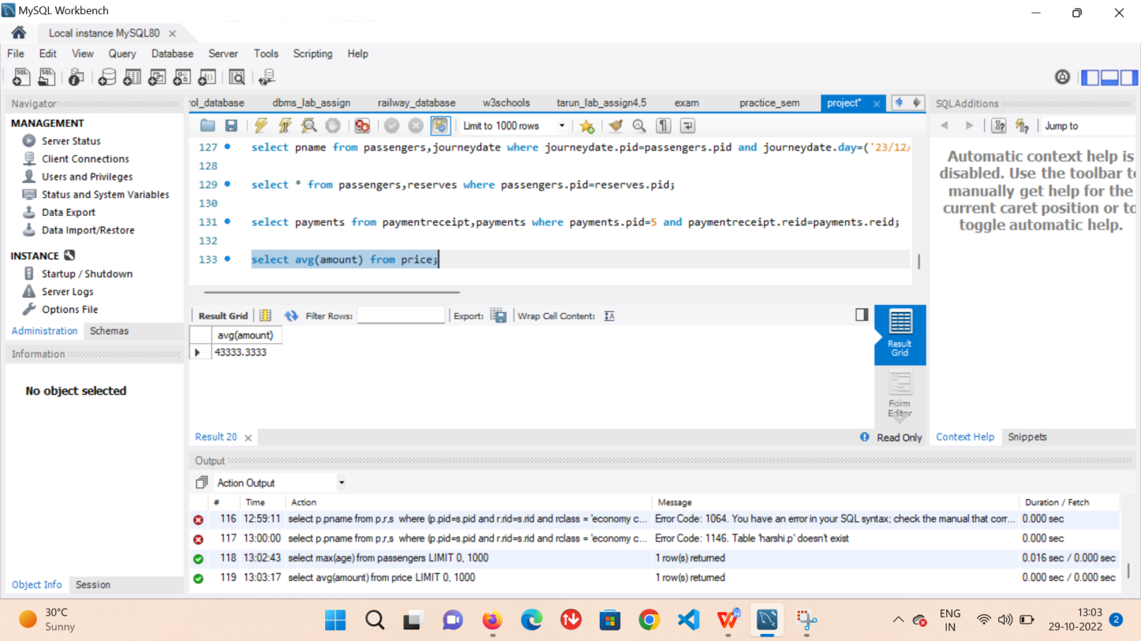

**DISTINCT COST**

Display how many passengers done the payment

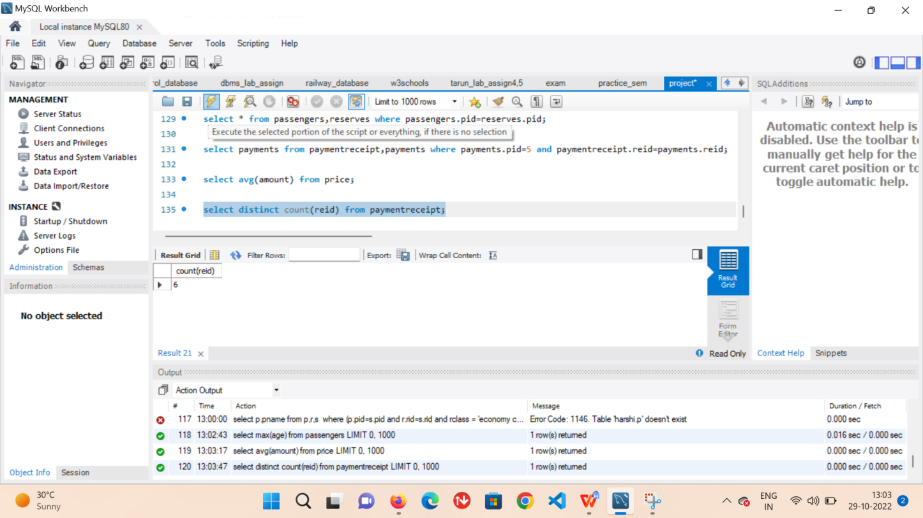

**MINIMUM AGE OF PASSENGER**

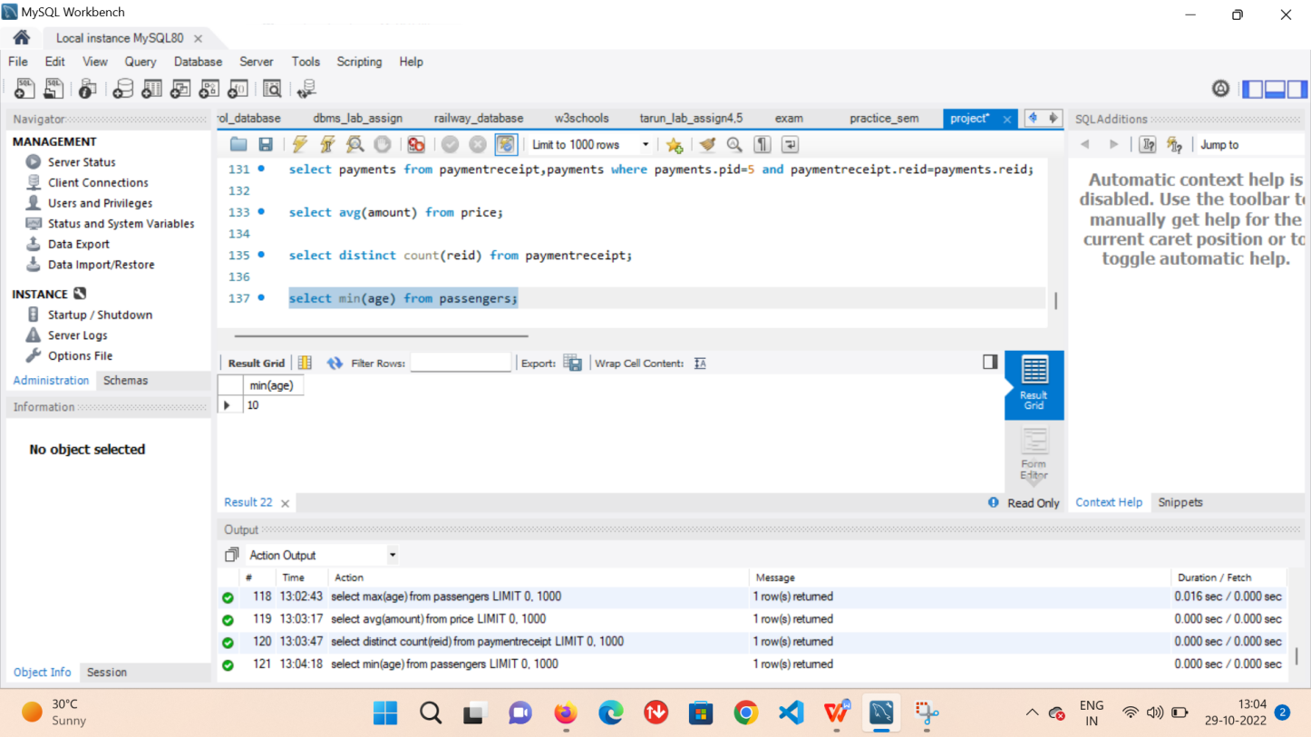

# JOINS

A Join clause is used to combine rows from two or more tables, based on a related column between them.

Cross jo n

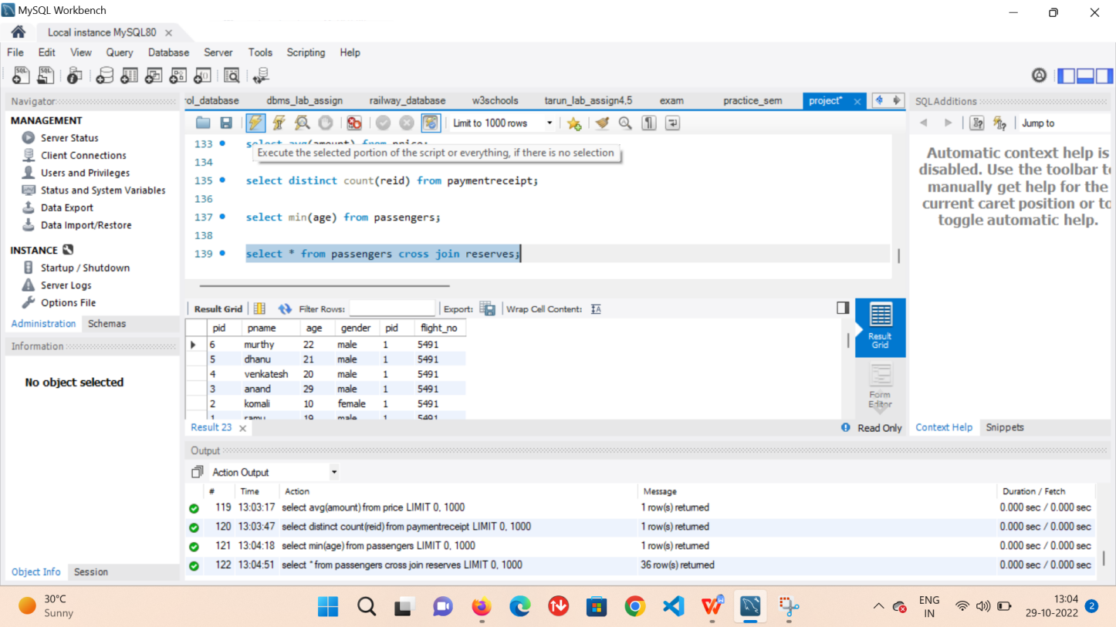

**NATURAL JOIN**

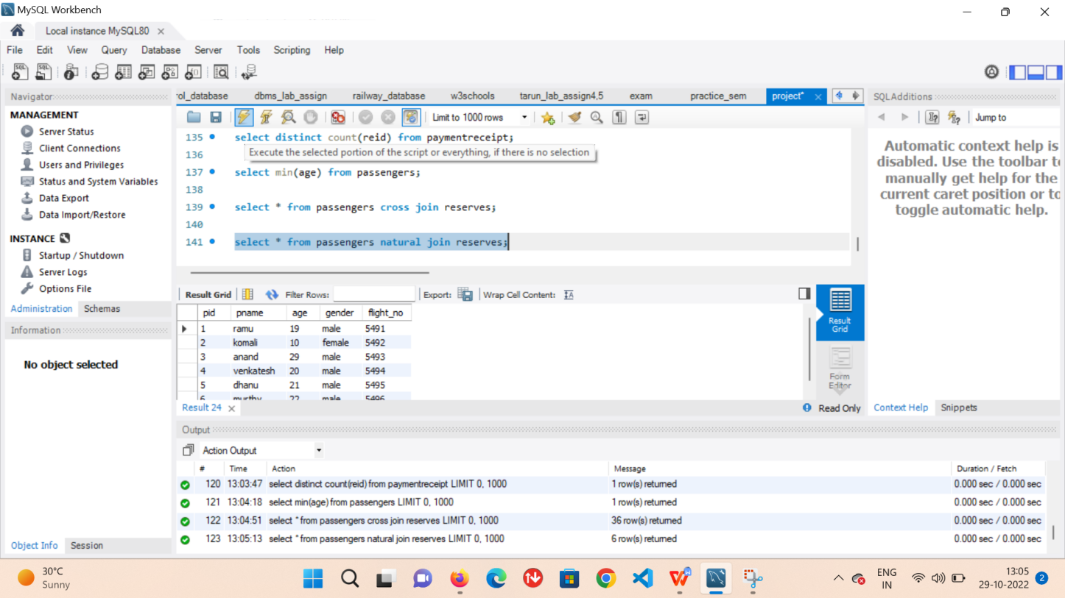

**INNER JOIN**

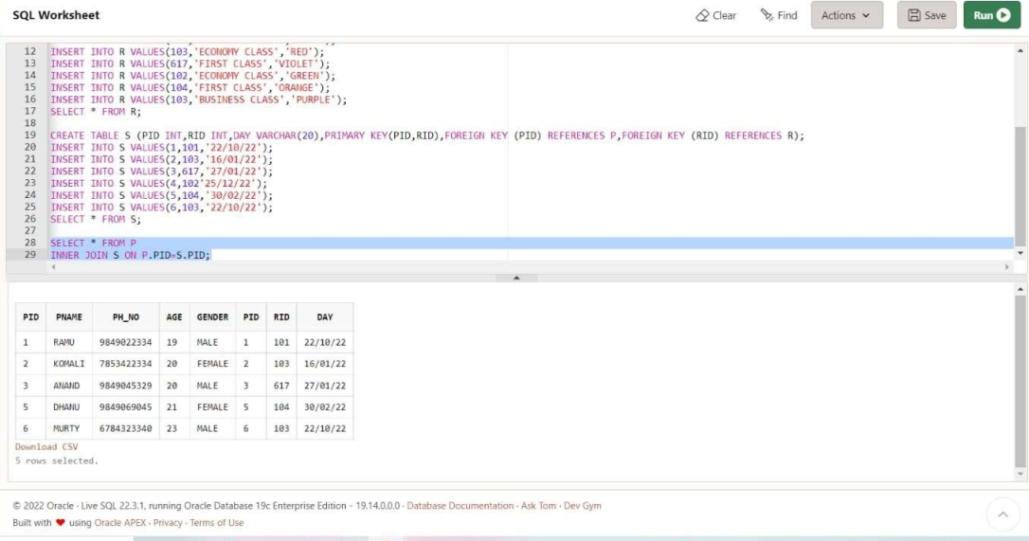

**LEFT OUTER JOIN**

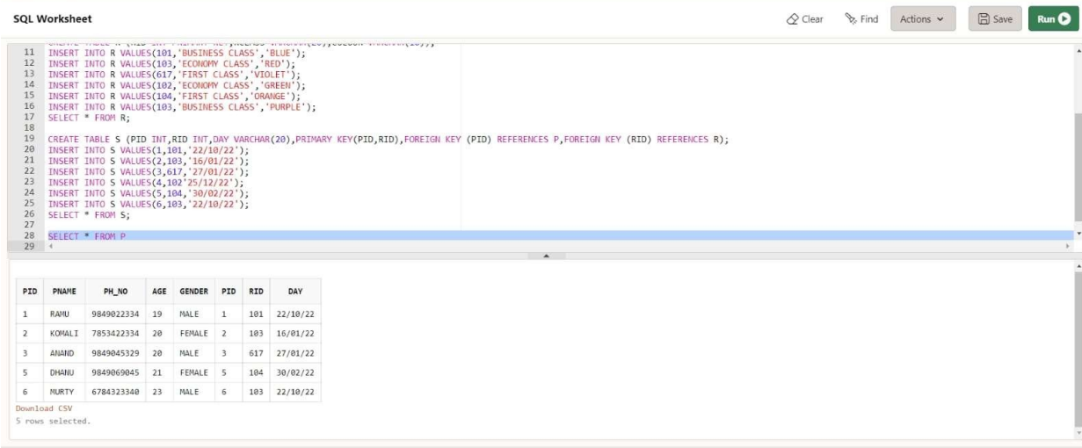

**RIGHT OUTER JOIN**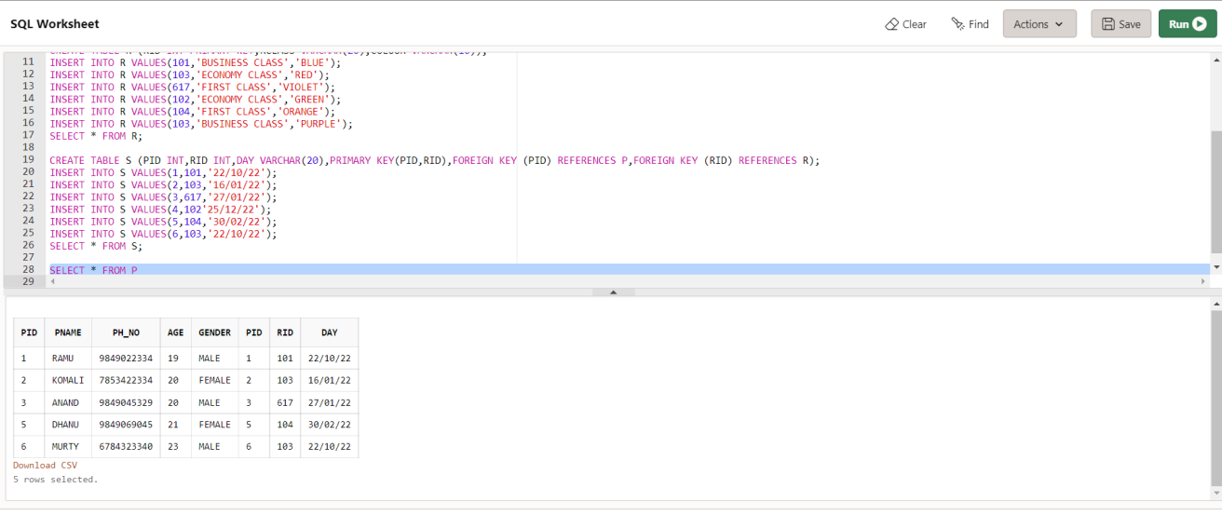

**FULL OUTER JOIN**

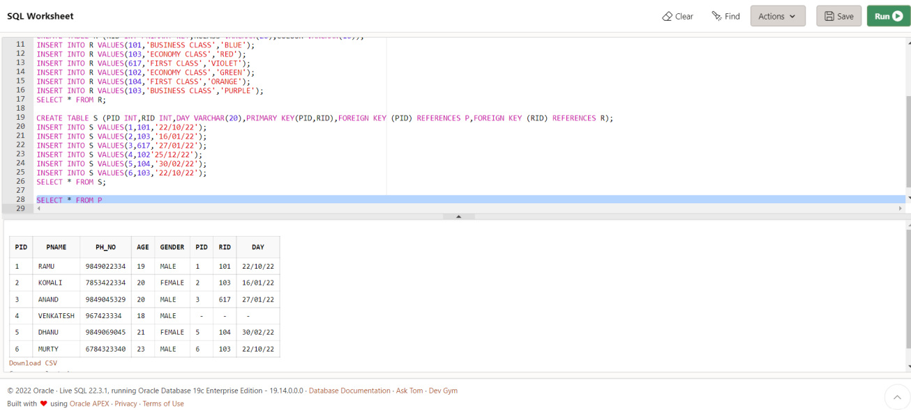

**Print passenger details whose amount is greater than 15000**

